Flight Tickets Booking/Search

# Technologies used

* HTML
* CSS/SCSS
* Core JavaScript
* Minimal jQuery

# Plugins used

* Open Sans Google font used (Online)
* jQuery UI plugin used for date picker

# Overview

We can search the flights by entering from, to locations and departure date if it is a One-Way trip, the same when select Round trip we have to fill return date as well to search the flights.

# Trip type, Traveller(s) and Class type

We have an option to select the trip type like “One-way” or “Round Trip”, by default “One-way” trip option enabled (checked). We can select the travelers count with the option of “Adult *(12+ years)*, Children *(2+ 12 years)* and Infant(s) *(below 2 years)*” by default, Adult count 1 added at max we could add 10 members and min 0 each section. We have option to select the class type like Economy/Premium Economy/Business/First Class by default Economy selected.

## Travellers Information screen

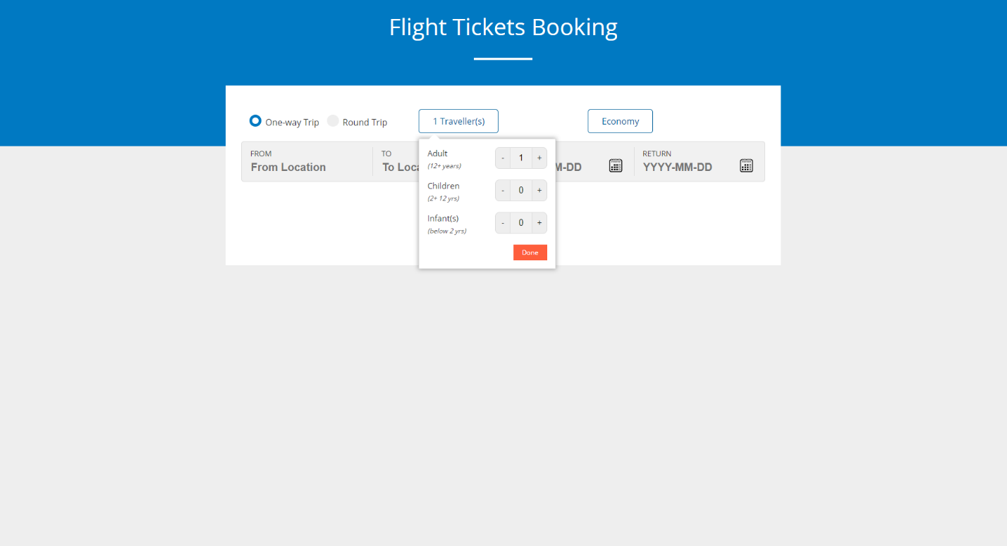

## Class type selection

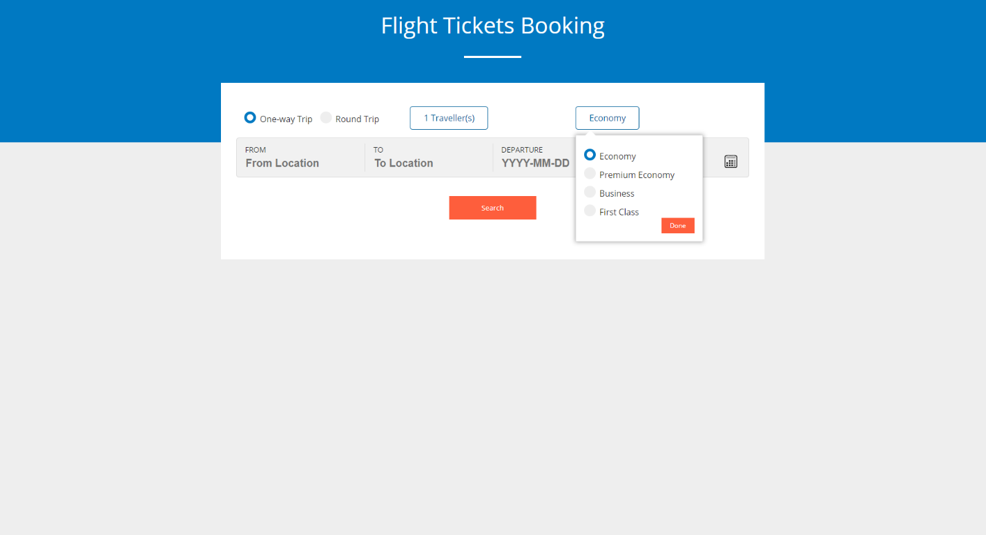

# From and to locations

We have to select the from, to and departure date information to search the flight for one way trip and when we select round trip option return date field will be enabled. Therefore, all the fields are mandatory to search the flights. From and to locations should not be the same, we are validating it in UI and throwing an error. When we enter from location, we are populating the suggestions based on the available airports in India (we have the [Indian airports list](../JSON/indian-airportslist.json) JSON) from JSON. The same will be applicable for to location as well.

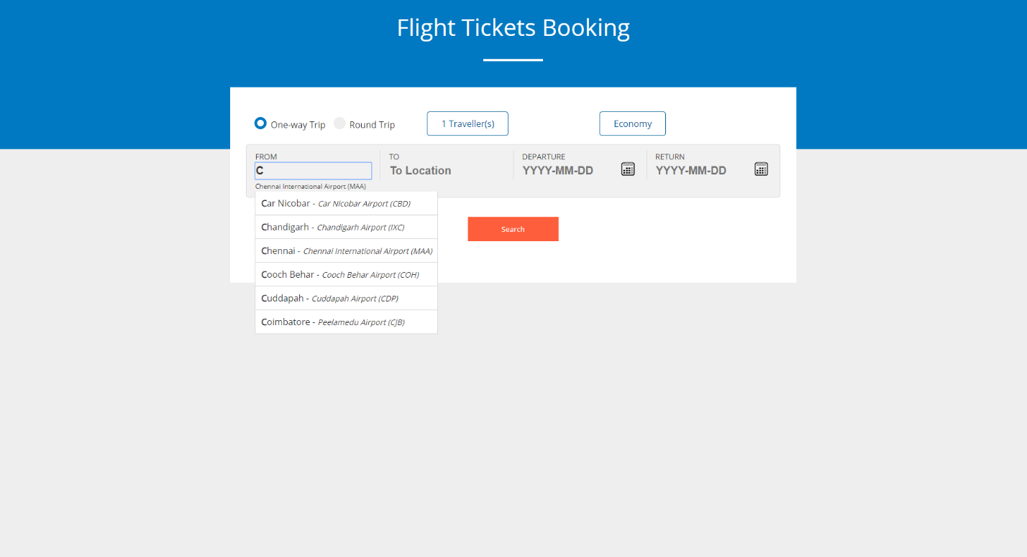

# Departure and Return date

Departure date enabled from today’s date and future dates disabled to select, based on the departure date return dates enabled if we are booking for round trip.

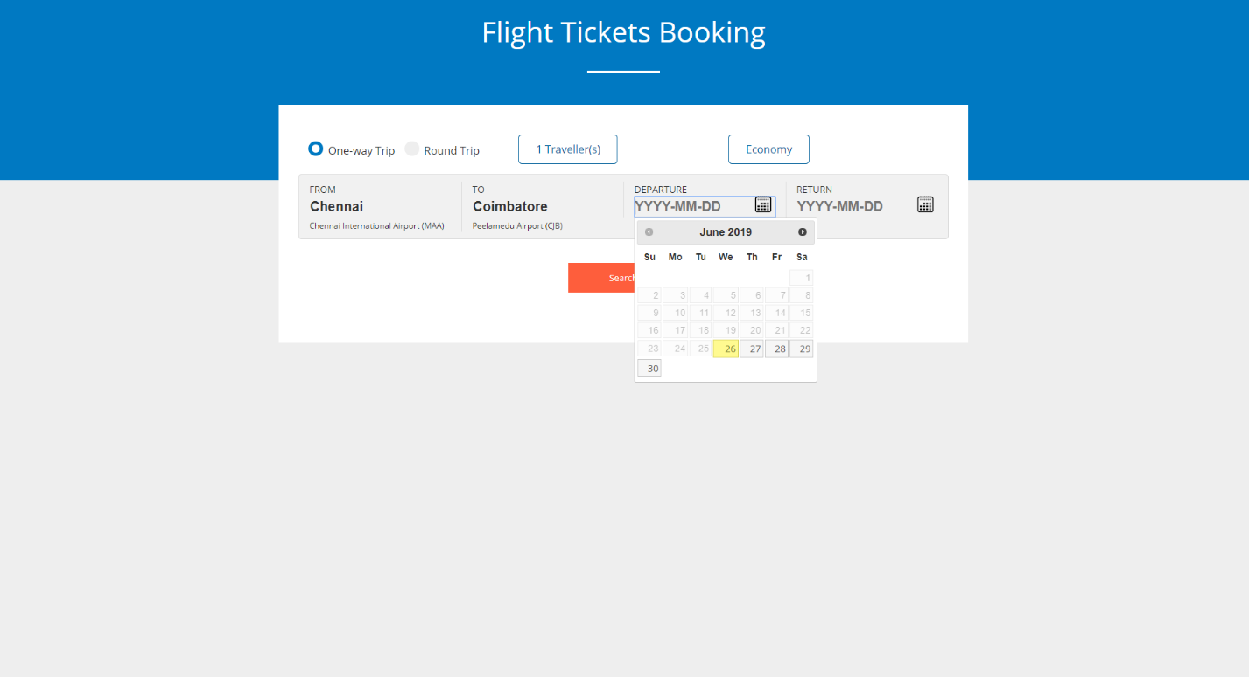

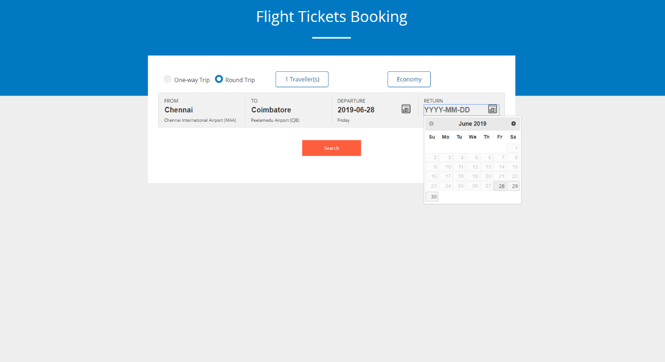

# Search results

Based on the given information, the flight results displayed in UI with the flight name, departure time, from location, travel time, stop type, arrival time, arrival location and price. We have an option to filter and sort the flight results as per need.

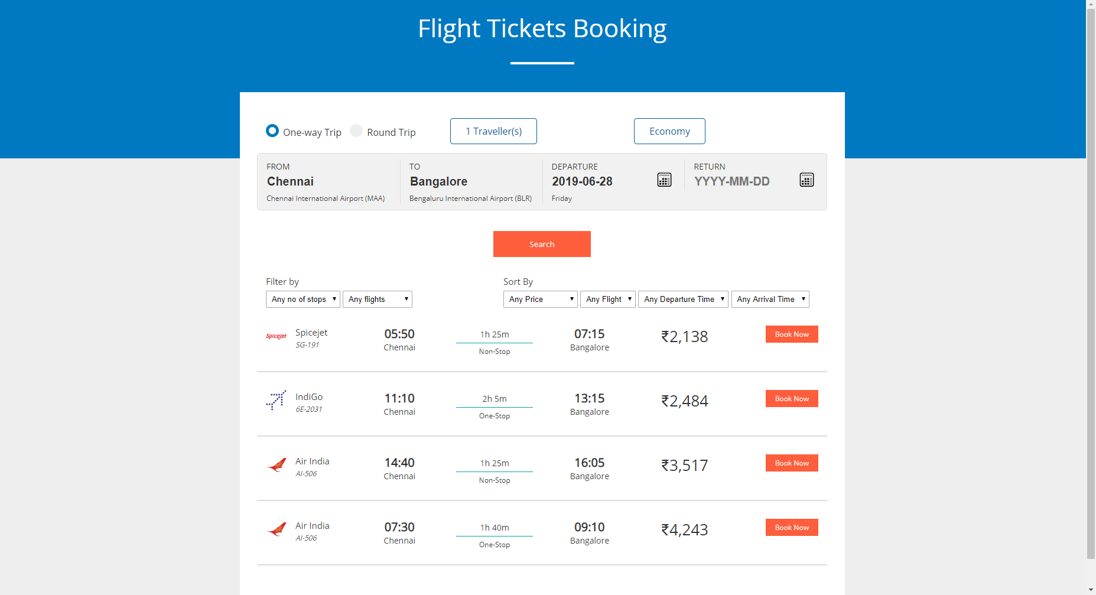

# Test data

We have some list of flight information for testing purpose, please use below some test date or refer the “[flight-info.json](../JSON/flight-info.json)” file to know more.

|  |  |  |
| --- | --- | --- |
| From location | To location | Departure date (YYYY-MM-DD) |
| Chennai | Bangalore | 2019-06-28 |
| Coimbatore | Chennai | 2019-06-29 |
| Chennai | Bangalore | 2019-06-28 |
| Chennai | Bangalore | 2019-06-28 |
| Mumbai | Bangalore | 2019-06-29 |
| Coimbatore | Bangalore | 2019-06-28 |
| Coimbatore | Bangalore | 2019-06-29 |